Call for the University Prize 2023 in the Category Teaching and Learning – Nomination

Please send the fully completed and signed form with the additional documents – in one PDF file – to Ms Beate Nenner by 6 October 2023, 23:59 hrs. (deadline) exclusively by e-mail (unipreis@verw.uni-koeln.de).

Documents to be submitted
- the fully completed and signed nomination form (mandatory information is marked with an *)
- a detailed presentation of the teaching/learning offer or project (for information and key questions, see pages 4–6 of this form)
- evaluation results (or similar, if no evaluation results can be provided in a substantiated manner)
- optional: a statement or a letter of recommendation (e.g. the Dean of the Faculty or the head of the central institution/student interest groups) (max. 5 pages)

Information on the teaching/learning offer or project
Title/name:*
Format (please tick all that apply):*
O Seminar
O Lecture
O Internship
O Tutorial
O Lab
O Workshop
O Self-study
O SI Offer
O Project
O Programme
Other (please specify):
Period of implementation:*
Formal responsibility (e.g. Faculty, central institution, project management):*

Scope (e.g. SWS, credit points, learning time within the project):*

Number of participants:*
Composition of the learner group (subjects, Faculties and/or central institutions, if applicable):

Link to the teaching/learning offer or project:

Additional awards or sponsorships of the offer or project, if applicable:

Information about the nominee(s)
Nominated person (academic title, first name, last name):*

Field of activity (e.g. Faculty, chair, central institution):*

The nominee's e-mail address:*

Other nominated persons (academic title, first name, last name, field of activity, e-mail address), if applicable:

Evaluation information
The teaching/learning offer or project was evaluated by the learners.
Period and context of the evaluation:*

Brief summary of the evaluation results:*

Brief justification for the proposal
Please explain your suggestion here in a maximum of 500 words*:

Place and date:*
Signature(s) of the nominee:*

Notes on the detailed presentation of the proposal
Please attach a detailed written description of the teaching/learning offer or project in the form of a PDF document to the nomination. The description should not exceed 3–5 pages.
Please explain why it represents an outstanding achievement in the field of teaching and learning and why the persons involved should be awarded the university prize. Please explain to what extent the following aspects apply to the teaching/learning offer or project:
- It is characterized by a particularly exemplary, successful and forward-looking implementation of the mission statement of teaching and learning as well as the quality objectives.
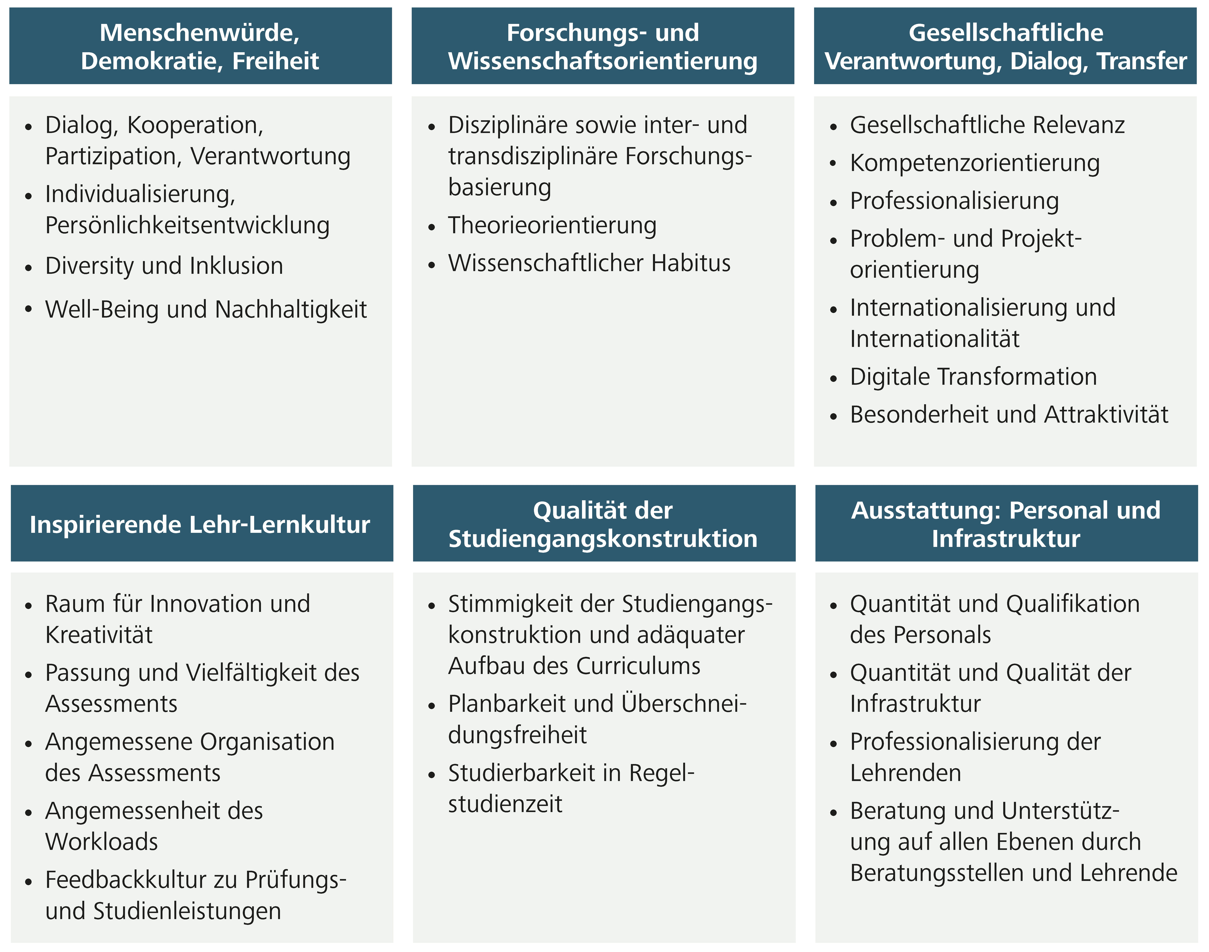
The following quality criteria for teaching and learning are derived from the mission statement and quality objectives of teaching and learning.
- It is innovatively designed.
- It has the potential to transform teaching and learning at the University of Cologne.
- It is exemplary for teaching and learning a) in the Faculty, b) in the university and c) beyond the university.
- It is characterized by being particularly student-focussed.
- It promotes digital education (in line with the concept of the University of Cologne).

The following questions can be used as a guideline when presenting your proposal:
- Where is the teaching/learning program or project located (Faculty, central institution) and who is the target group?
- Did the offer or project take place online, as a hybrid format or on-site at the university?
- How was/is the teaching/learning programme or project thematically designed and how was it structured?
- What learning and educational goals or other goals were/are pursued with the teaching/learning offer or project? (e.g. personal development, filling knowledge gaps/gaps in the course offer, improved exam results, improved learning behaviour, university/professional contacts, special practice-/professional reference etc.)
- What competencies should the learners acquire by participating in the teaching/learning programme or project?
- How does the teaching/learning programme or project contribute to the promotion of digital education for participants?
- Which didactic approaches and methods were/are used, or which teaching/learning concept was/is implemented? (e.g. research-oriented or research-based learning, independent working, group work, promotion of active learning, micro-learning, blended learning, flipped classroom, project- or problem-based learning etc.)
- What tools have been/are used to promote and support the teaching/learning process?
- To what extent is the teaching/learning offer or project characterized by a societal (current) relevance? (e.g. assessment of the external impact, matching with currently relevant topics, addressing and answering acute societal questions)
- To what extent was the content and methodology design or action oriented toward the needs of the learners? (Objectives and achievement, skill-oriented, practical and research relevance, interdisciplinarity)
- To what extent and how has diversity-specific, inclusive and/or barrier-free access to learning been paid attention to?
- To what extent was there special/continuous/systematic feedback from learners? (e.g. evaluations, personal contact, written feedback)
- What is the innovation and role model potential of the teaching/learning programme or project?
- What are the unique selling points of the teaching/learning programme or project compared to similar programmes?
- To what extent is the teaching/learning offer or project sustainable: To what extent can it be applied to other areas of higher education? Can the teaching/learning offer or project be further developed and offered repeatedly and thus continuously?
- How do you assess the personal performance of the nominated person(s) and their contribution to the success of the teaching/learning offer or project?

